2021-2023 Neighborhood Economic Recovery Fund

The Neighborhood Economic Recovery Fund is designed to support community-led strategies to reignite the local economy with an intentional focus on promoting racial equity. This Request for Proposals (RFP) is funded through the Coronavirus Local Fiscal Recovery Fund (CLFRF) established under the American Rescue Plan Act (ARPA). Neighborhood Economic Recovery funding is administered through the Office of Economic Development (OED).

Projects can be community-based solutions to address the negative impacts that the COVID-19 pandemic and related public health measures had on neighborhoods and their local economies. Projects can help businesses, communities and local economies recover from those impacts. Neighborhood Economic Recovery funding can support a variety of activities and projects.
Examples of Eligible Projects include but are not limited to:
- Public and commercial space activations, such as, outdoor seating, retail/vendor markets, public art and music, community events and commercial space popups
- Digital equity projects, such as neighborhood digital marketplaces
- Communications infrastructure, such as websites, social media, and contact databases to promote community news and resources, and share stories of local businesses and events
- Physical Improvements, such as lighting, sidewalk cleaning, murals, façade
- Community safety projects, such as business block watches, community organizing
- Outreach to support businesses and residents, build partnerships and shared vision, and
- Other economic recovery projects specific to neighborhood needs
Minimum grants are $10,000, Maximum grants are $100,000

Application Timeline:
- October 72021, 5:00 pm PST: Deadline for submitting an application.
- October 2021: Applications will be reviewed and decisions made
- Early November 2021: Grant awardees will be notified.

Information Sessions: Online or in Person if allowed:
August 30, 2021; August 26, 2021; September 10, 2021.

Visit the OED website for more information: http://www.seattle.gov/office-of-economic-development

Application Instructions
Instructions
Applications are due 5:00 PM PST on Thursday, October 7, 2021 via the online grant portal. Late applications will not be accepted.
Follow these steps to complete your application.
1. Review the Funding Opportunity Guidelines and Requirements
This provides in-depth details about the funding opportunity, eligible projects and requirements.
2. Read these Application Instructions
Read the complete application questions and instructions in this document and gather any information necessary to answer the questions in advance of starting the application.
3. Read the FAQs
While we're always a phone call or email away to help you with your questions, many answers can be found in the Frequently Asked Questions (FAQs) to assist you in your grant application.
4. Write the answers to the application in a separate document.
We recommend writing your responses in a separate document first, so you can work on it over time and have a backup copy. Please note, this document is provided only for review and preparation purposes - all applications must be submitted through our online application.
5. Register in the online grant portal, Fluxx https://seattle.fluxx.io/user_sessions/new
Select the Create an account now button. You will need to create an individual user account for yourself with your name and email address. You will receive an email to verify your account. You will then create a password for your account and can login.

6. Start your application
Login to your account and click on the Office of Economic Development on the left-hand side of the screen. 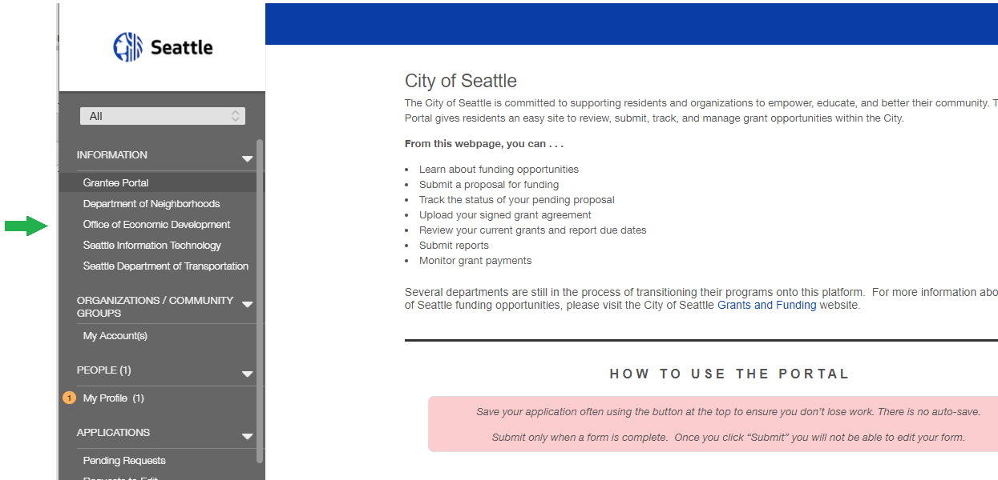
Scroll down and click on the Apply Now button.
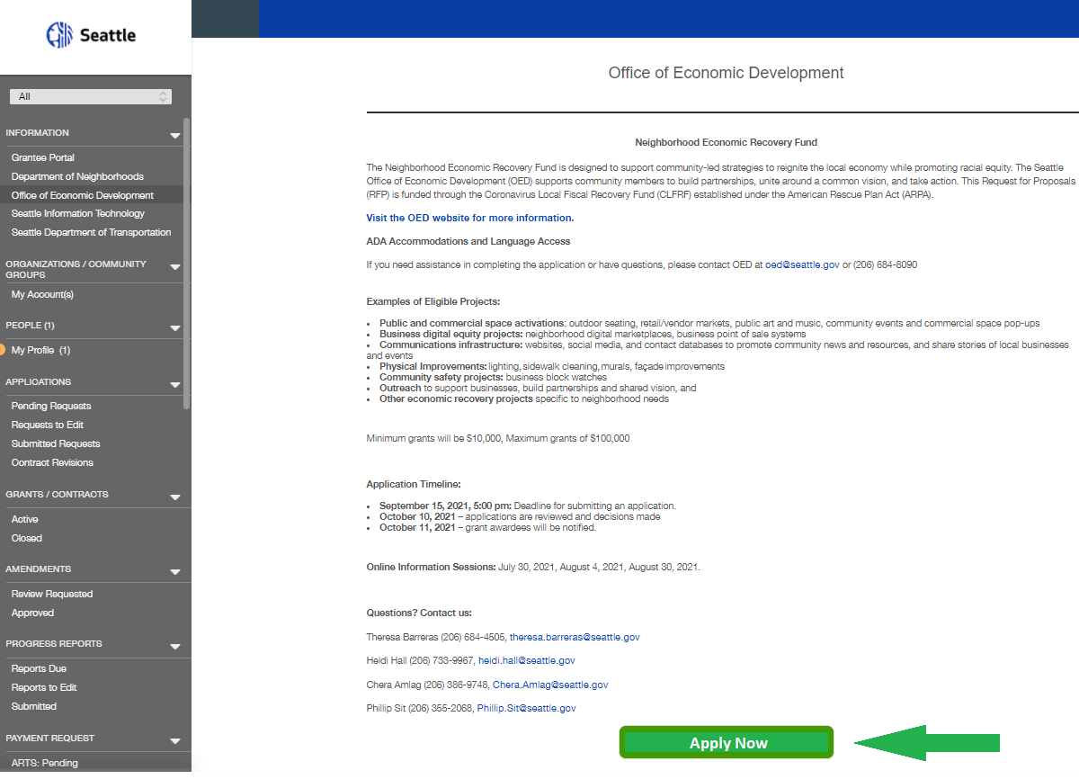
7. Enter your Organization Information
The Fluxx portal allows users to be associated with multiple different organizations or community groups. Therefore, you will need to enter the Organization or Group that is applying for this opportunity. Since this is a new portal, your organization is probably not registered and you will need to create a new one. You only need to enter the required information.
8. Answer the application questions.
The system does not autosave, so be sure to click Save and Continue on the bottom as you go. You can also click Save and Close and finish it later. Cancel will cancel your work without saving.
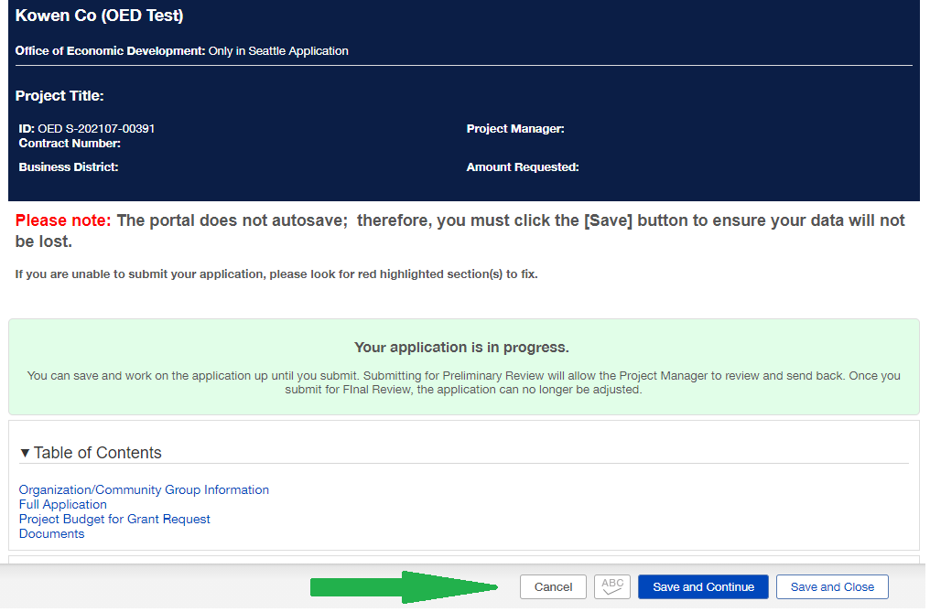

After you save and close, you can click the Submit for Preliminary Review on the bottom right to receive feedback from an OED staff person before the deadline. You can also click Edit at the top right to edit the application. Once you are finished, you can click the Submit for Full Review. If you click Withdraw, your application will be cancelled.

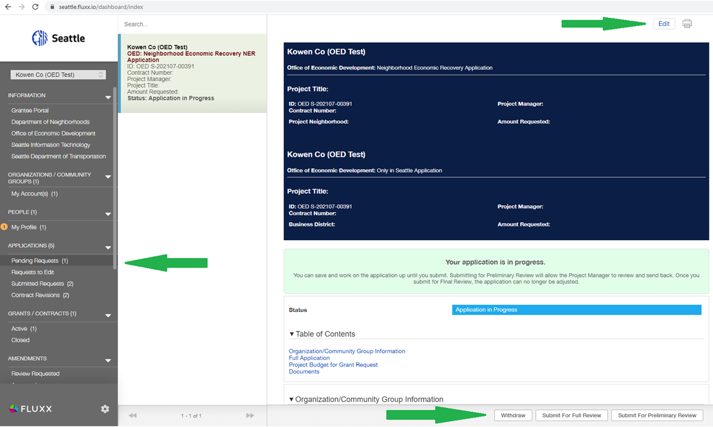

Click the gear symbol on the bottom left and then Logout to log out of the system.

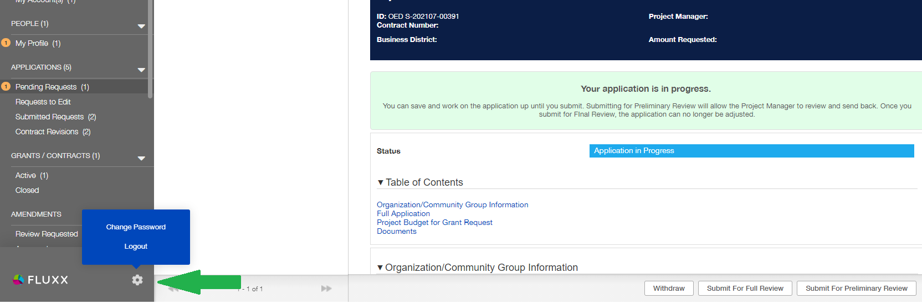

Are you considering applying and have questions? Contact the team to get help.
Please submit all final applications through the website. If you need help during the application process , please contact any staff member:
- Theresa Barreras, Business Districts Manager at (206) 684-4505 or theresa.barreras@seattle.gov
- Heidi Hall, Business Districts Advocate at (206) 561-2135 or heidi.hall@seattle.gov
- Chera Amlag, Business Districts Advocate at (206) 386-9748 or Chera.Amlag@seattle.gov
- Phillip Sit, Business Improvement Area Advocate at (206) 355-2068 or Phillip.Sit@seattle.gov
Application
The following is the information that you will need to provide on the online application. Review and prepare your answers before starting the online application.
- Organization / Community Group: Type the first three letters and see if your organization appears. If it does, click on it and double check the information for accuracy. If it does not appear, it probably is not yet in the system. Click Add New and enter the following:
  - Organization Type: If your organization has a Federal Tax ID number, then select Organization. If not, select Community Group.
  - Please select any topics you may be interested in applying for funding.
Select at least one (REQUIRED)
  - Mailing Address 1, City, Zip/Postal Code, Email, Click Save when finished
  - Primary Contact: Select yourself or Add New and enter
    - First Name, Last Name, Email, Mailing Address, City, Zip, and Click Save
  - Primary Signatory: Select yourself or Add New and enter
    - First Name, Last Name, Email, Mailing Address, City, Zip, and Click Save
- Add new contacts: Can leave blank or select Yes or No. Add more contacts if you like
- I agree that I am authorized to submit this application on behalf of the applicant organization, and that the statements herein are true, complete and accurate to the best of my knowledge:
  - Select Yes or No (REQUIRED)
- Did someone help you complete this application? If someone is helping you to fill out the online application who could also help with any follow up questions, please enter their name and contact information.
Full Application
- Project Title: Please give your project a brief title/name.
- Amount Requested: Enter the dollar amount of your grant request
- Project Start Date: Enter the date your project will start
- Project End Date: Enter the date you think your project will end. Latest date is December 15, 2023
- COVID Impacts
Briefly, but explicitly, describe the financial hardships your community and/or your organization faced resulting from COVID-19 pandemic and closure impacts. What problem/issue are you trying to solve with your project?
- Project Summary
Please describe your project proposal. Include how your proposal will address the impacts from COVID and contribute to the City’s equitable recovery results:
- Neighborhoods and communities rebound from the impacts of COVID-19 and thrive.
- Entrepreneurs and small businesses can recover from the impacts of COVID-19, stabilize and grow their businesses.
Your proposal should clearly outline how it will center racial equity in its support of Black, Indigenous and People of Color (BIPOC) business owners and/or BIPOC communities and how it will help businesses and communities recover economically from COVID impacts and stimulate neighborhood economic activity. A maximum characters of 2500.

HINT: Type or paste the description of your project into the answer box. You can use the text-rich formatting options at the top of the box to format your text. You have space for 2500 characters, which includes spaces, letters, bullets, etc. The characters remaining shows up below the box to help you count.
- Project Neighborhood
Please select the neighborhood where your project will be located. There is an additional question below where you can be more specific about the location if needed.
HINT: scroll to find the neighborhood, click on it to highlight it and click the arrow to move it to the box on the right.
- Project Location
Provide the specific location of the project such as the name of the business district, the address of an activation project or event, or other geographic location. (Maximum 250 characters)
- Community Supported
Describe how you and/or your organization is representative of and/or has a demonstrated history of being connected to the community your proposal seeks to serve. You can list other community-based organizations that are working on the project with you, list individuals in your group and their community affiliations and list examples of your work within this community.
(Maximum 1500 characters)
- Project Budget for Grant Request
Please click the plus sign to enter a project budget. Only add one budget form. Include the budgeted amounts for individual cost types. There are general cost types already provided and you can add additional cost types at the bottom to best reflect your project budget.
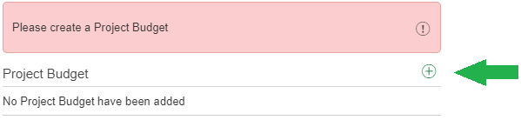
After clicking the + sign, a budget form opens up that looks like the image below.
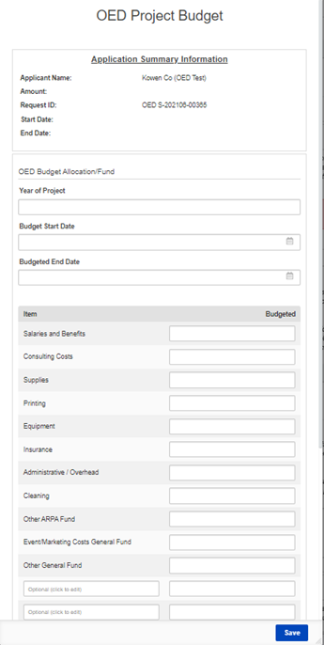
Fill out the form:
Year of Project | Enter 2021
Budget Start Date | Enter a start date
Budgeted End Date | Enter an end date
Enter the costs anticipated in your project budget. Use these expense categories if applicable. You can add additional expense categories in the blank boxes at the bottom called Optional.
Item | $ Amount
Salaries and Benefits
Consulting Costs
Supplies
Printing
Equipment
Insurance
Administrative / Overhead
Cleaning
Other ARPA Fund | Leave this blank for now
Event/Marketing Costs General Fund
Other General Fund | Leave this blank for now
Optional (click to edit) | Enter additional expenses on each line as needed
- Budget Narrative
Please provide a narrative explanation of the project budget request for this grant. If the budget shown above is greater than your grant request, please explain if you are contributing other sources of funding to your project. A maximum characters of 1500.
- Documents
OPTIONAL: You can attach documents that support your application such as activation design plans, examples of your previous experience in the community, or support letters from community partners.
Click the + sign to attach a document. Then click Add Files and find and select the files on your computer. Then click Start Upload.

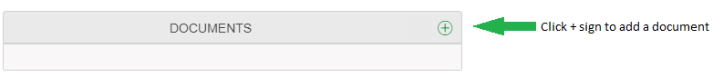
ARE YOU READY TO APPLY?
When you are ready to begin your application, go to the Fluxx portal and click the Apply Now button. Are you considering applying and have questions? Contact the OED team to get help.
Please submit all final applications through the Fluxx portal website. If you need help, please contact any OED staff member (contact information on page 6 of this document).

